2024-02-24 - Handout – Understanding LLMs and How ChatGPT Works

# Agenda

* What is a Transformer Model?
* What are LLMs?
* What is GPT (Open AI’s LLM)? How was it built?
* High Level Architecture of how ChatGPT works? What makes it have conversations with us?

## GPT Training and Answering

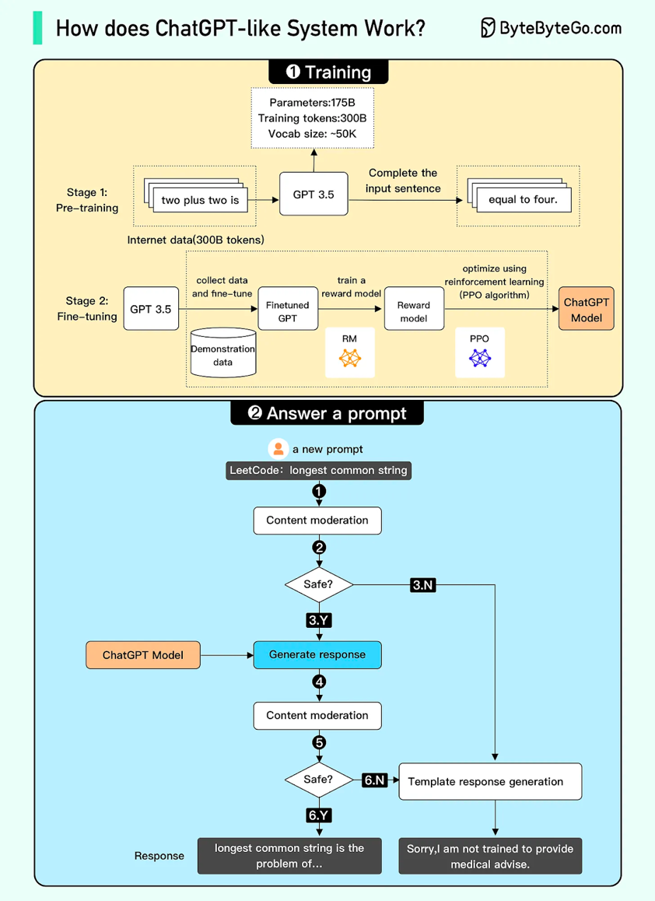å

**Credit**: ByteByteGo (<https://blog.bytebytego.com/p/ep-44-how-does-chatgpt-work>)

## HLD of ChatGPT

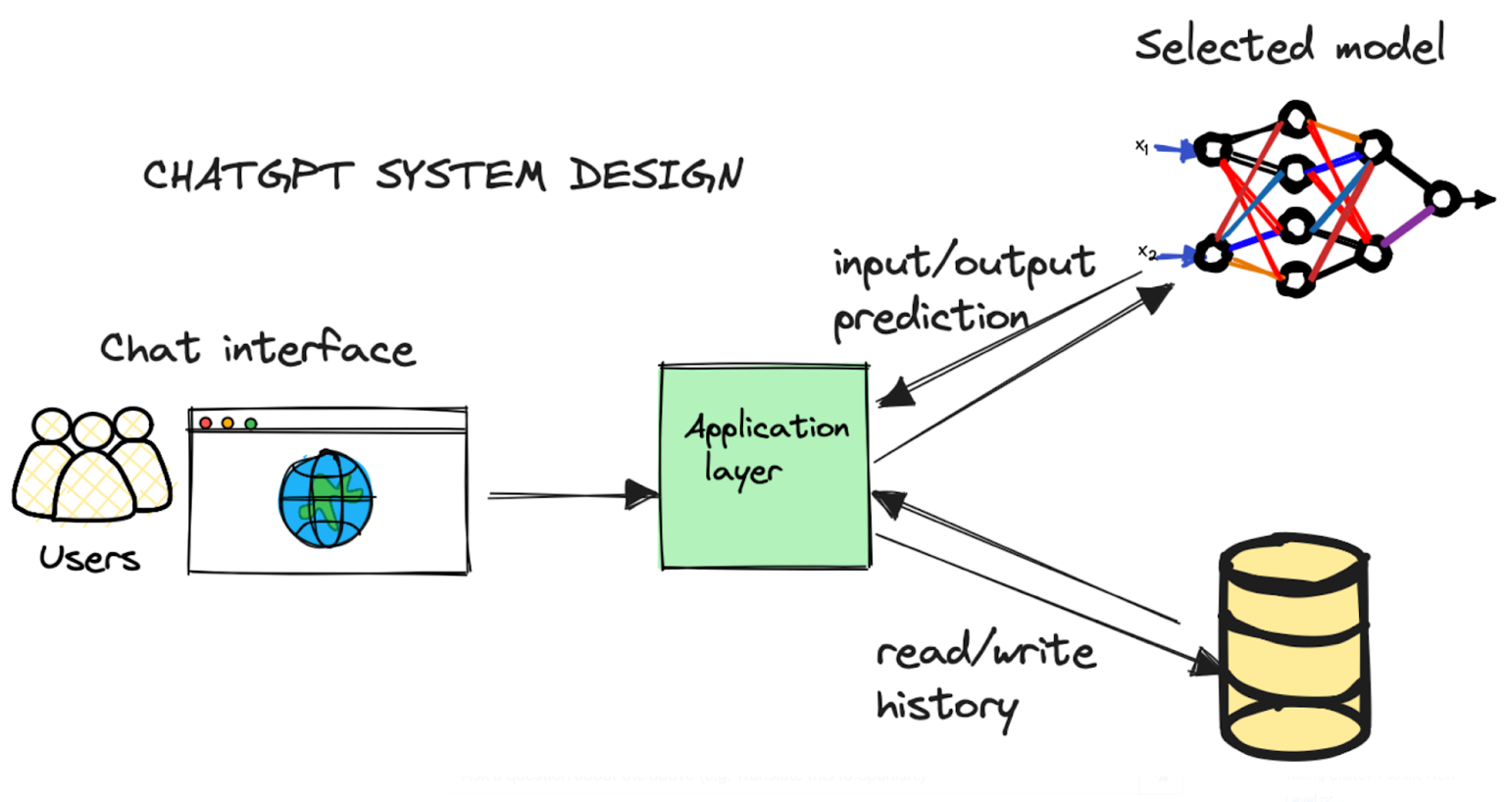

**Credit**: Algodaily (<https://algodaily.com/lessons/chatgpt-system-design>)

**Functional Requirements:**

* Support natural language conversation.
* Handle millions of users
* Low latency response
* Moderated response without bias, explicit nature of content or misleading information
* Secure storage of all the data.
* Interpreting requests and selecting the appropriate model - Text interpretation and generation, Image interpretation and generation, Code interpretation and generation